**Is This The Most Powerful Open-World Game Engine Yet?**

For the upcoming open-world vigilante/hacker game *Watch Dogs*, European gaming giant Ubisoft has created its first next-gen game engine called Disrupt. We spoke with the game's lead producer, Dominic Guay, about the capabilities of the new engine and the challenges of scalability and simulation.

By [Kevin Ohannessian](http://www.fastcompany.com/user/kevin-ohannessian)

In Chicago of the near future a unified OS connects the city's many systems such as electricity, traffic, and mass transit, to a single network. As Aiden Pierce, you are a hacker turned vigilante who will use all your technical prowess in this connected city to stop violent criminals and corrupt men of power. You hack a traffic light to turn green, you hack a train to carry you to your destination, you hack a draw bridge so it opens behind you, giving you a clean getaway from the police. This is *Watch Dogs*, an open-world game from Ubisoft.

When it was unveiled last year, many thought it looked too good for the current generation of video game consoles. Ubisoft soon revealed that the game was destined for the next generation debuting the following year. Well, it is 2013 and Ubisoft has shown us what the game looks like on the PlayStation 4, likely launching in November. But in creating the game, the company had to create a new engine that would not only work with the more powerful machines to come, but the hardware out now. "When we started building the [Disrupt] engine, we started right away with scalability in mind," says [Dominic Guay](http://www.fastcompany.com/person/dominic-guay), the game's lead producer. "We told engineers that we need to support existing consoles because there are tens of millions of people who want to play the game that have those consoles."

But when Guay and his team started creating the Disrupt engine four years ago, they wanted to build a next-gen engine, not only because it was destined for more powerful hardware, but they wanted new features beyond their current games. Guay said, "We call it Disrupt, for two reasons. One is a tribute to Aiden's abilities, and the other is because we wanted to break with some paradigms of past engines." They took pieces from the Anvil engine that powers the *Assassin's Creed* series and the Dunia engine that powers *Far Cry 2* and *3*. Then the team built it up along two guidelines, Dynamism and Connectivity.

Guay wanted a future Chicago that felt alive, that responded to player's action. Guay gives an example seen in various demos of the game. "We had Aiden Pierce walk up to an intersection and hack into the traffic light, causing an accident that stopped his target. You can do the exact same thing in any game engine: You would have a given intersection, at a given time the player would walk to it, then there would be a scripted event of an accident triggered by the player. The outcome would probably always be the same: The cars would end up in the same context and the same result, and the designer would have instructed the AI on exactly what to do. Not in*Watch Dogs*. In *Watch Dogs* you can go to any of the hundreds of intersections in the city that have traffic lights and you can hack them at any time you want, for whatever reason you have. You can do it any time of day, in any traffic condition. Will there even be an accident? I don't know. It depends on the traffic density at the time, also on the AI of the drivers," says Guay.

The Dynamism goes beyond car accidents. The game has a day and night cycle, with the traffic and citizen behaviors changing based on the time of day. Likewise, dynamic weather systems affect citizens and traffic. The game has complex simulations of water, rain, and wind. Guay says, "All of us know from big cities that wind tunnels are created, how passing of cars creating wind vortexes and impact objects around it. Or how the wind will affect the water, or how waves are created by the passing of a boat, or how those waves will impact other boats passing nearby. Those are details that show how we are focused on dynamism in every layer of the game."

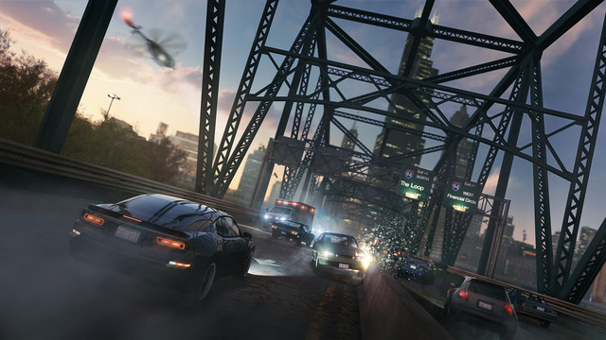

But it may be the citizens themselves that are the most dynamic. Beyond the aforementioned reactions to traffic and weather, the citizens react directly to the player's actions as the game's protagonist Aiden Pierce. Some will run in fear, criminals will attack in anger, witnesses will call the cops, people will react to how violent you are, and the police will respond to your actions. Beyond the immediate AI behavior, the game has a reputation system where the city's opinion of you and actions—from citizens, social media, and corporate media—will change based upon what kind of vigilante you are and the choices you make.

That citizen behavior was the biggest challenge, according to Guay. "The hardest part to pull off is AI, especially human AI, the people on the street. In the chaos of the environment, if you have 30 people reacting to something, you still need to cut corners a little bit, because you can't process each of those 30 AIs as if they were two AIs in a co-op game. You need to spread the processing across all those characters, but still we want to have believability in those characters, to feel real and be able to react all the chaos that could happen," says Guay.

The other axis that the Disrupt engine was built on was Connectivity. For a game that is about hacking, this means multiple things. There is the gameplay, where most objects in the world feature a network component that the player can hack and manipulate, including the cellphones of the citizens around you. There is also the in-game connectivity of installing and using apps on Aiden's in-game cellphone—hear a song on a radio that you like? Analyze it with an app and buy the song on Aiden's phone.

But the true connectivity of the game is found in its online features that move the game beyond a typical single player experience. "We've all been there: We play an action game, an epic adventure of a hero. And when we go in multiplayer, we will have a lobby and we will end up playing capture the flag. It feels clunky," says Guay. "What we want to do is connect single player and multiplayer in new ways." Players will be able to jump into other people's single player games and fulfill hacking contracts. They could watch the other player by using cameras, or hack into their cellphone and install spyware. This is all done without lobbies or loading screens, with everything in the game ready to be online or not, in what they call Seamless Multiplayer.

And both the single and multiplayer gameplay can be affected by a Companion App here in the real world, that Ubisoft has been working on for years. So you will be able to hack friend's games from your Android phone or do hacking tasks for your version of Aiden Pierce on your iPhone. "You will be able to do all the things Aiden can do on the ground. You will directly be able to play with gamers who are on consoles or a PC. That could be true if you are sharing a couch with them, or even if you are on the bus and completely outside," says Guay.

Beyond the Disrupt engine's goals of Dynamism and Connectivity, there are other next-gen facets. Part of it was the tools they needed to build the city of Chicago. "One of the challenges was to build that city and be able to modify it as we went along. And how to do that without having to move every little object in the city if we change a road. So we had many tools to build," says Guay. "Also, it maybe sounds trivial, but how do you manage to work collaboratively with hundreds of people on such a compact, dense city? So we had to lot to think about in terms of work flow and how do you bring people from four different time zones to work on the same city."

And this is especially important considering the size and details of*Watch Dogs*'s Chicago. "We have the whole city. You can go beyond the city limits. You can go on the lake. You can go under the city. Ultimately, it's not about the size—because that doesn't necessarily make it more fun—it's more about the depth and the density," says Guay. "It would've been easier to add a little more space than adding the undercity. But the undercity was so much cooler, because we could have all those access points between the undercity and the upper city. We have density in interiors. We prefer to have the same amount of content that we could spread out and try to bring it closer to one another."

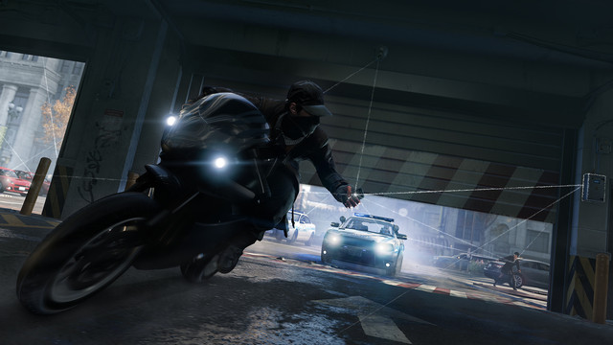

Yet all of this detail in the Disrupt engine had to also serve the current gen, not just the next generation of video game consoles. Ubisoft intends for the game to be a powerful experience on all consoles, but the PlayStation 4 and new Xbox coming out this holiday will really let the game shine. It will feature things like more citizens on screen and more visceral wind or water effects. Guay says, "The fidelity of the water we are getting on our PlayStation 4 version is absolutely phenomenal. Sometimes it looks like real water. We are not going there on Xbox 360 and PS3. It means that it will be more simple water simulation, but it's the same game experience. That's the kind of thing we are doing."

All of this effort with *Watch Dogs* and the Disrupt engine is to create a highly detailed, living version of Chicago that actually reacts to the players and their actions. "My ultimate dream is that the memorable moments of *Watch Dogs*, the thing you talk about when you finish the game as a cool moment, are not scripted, are not cinematics, are not a moment that was authored by our designers," says Guay. "I hope it is a moment that was authored by the plans the player made that they tried to execute, that they were creative, they had to improvise because things didn't work out, but ultimately something unique happened. They lived this and they consider it their moment, their story, not the one we built. That's my hope. And I think we are going to be able to achieve it."